For this task I have used the credit card default dataset.

* Data

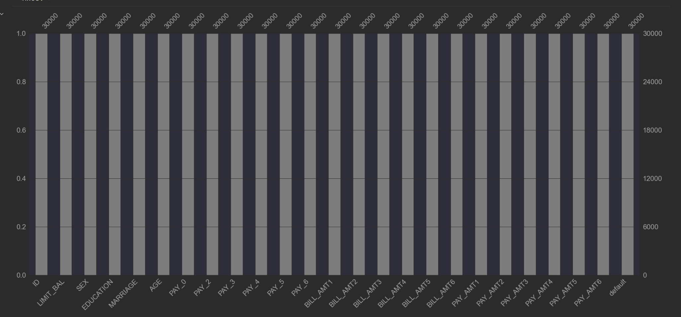

* Hyperparameter tunning set

The following hyperparameter set has been used in finding the best combination of parameters which generates the highest accuracy score of the training dataset.

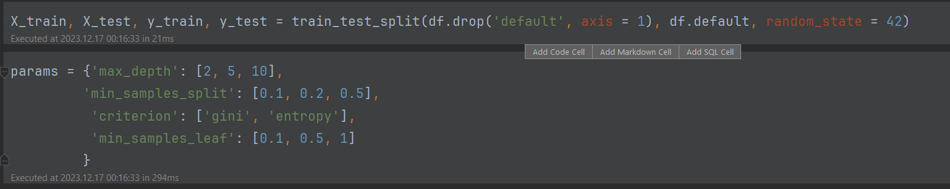

* Results of the models

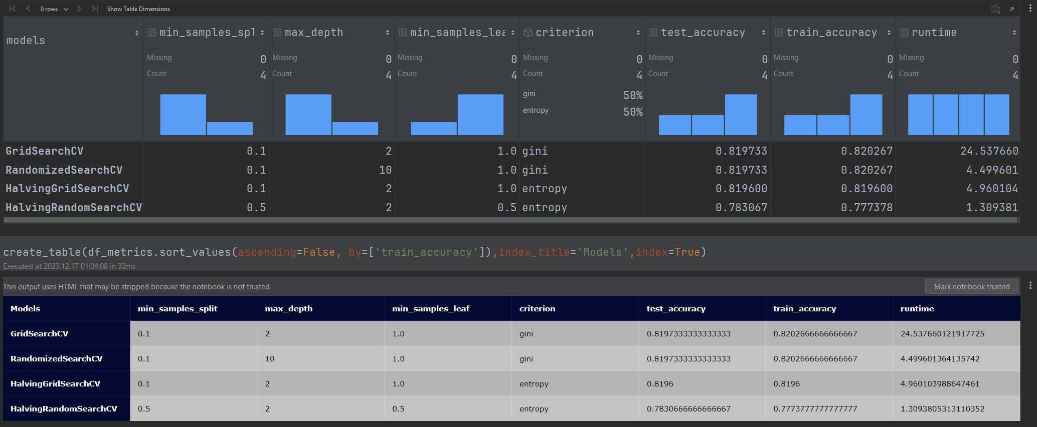

From the above table we can see the best Accuracy scores of 0.820267 are generated by GridSearchCV and RandomizedSearchCV models, but the RandomizedSearchCV has much better execution time of 4.499601 ms.

The shortest execution time of 1.309381 sec is run by HalvingRandomSearchCV model, but that model has the lowest Accuracy score of 1.309381.

There is some trade-off between Accuracy score and Execution time between the models

Good work Vincent!

I was very suspicious about the Accuracy of your models, so high...

Run the search models with seaborn iris dataset and came to very similar results.

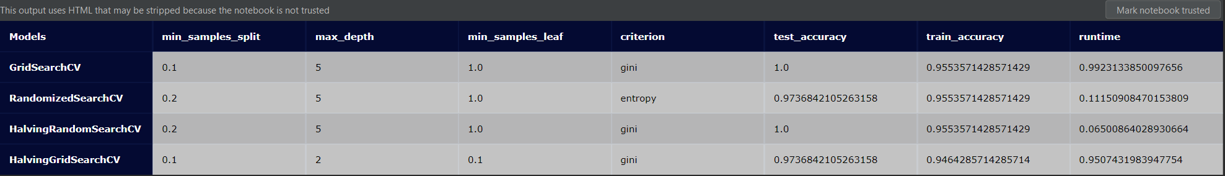

Hey Henry,

I also notice that it looks like that ‘iris’ dataset has been optimized maybe for classification tree demonstration, because the accuracy score is almost 100% and hyperparameters has almost not much influence to change the accuracy. The algorithms of those search models get almost the same accuracy.

Run the same python code for ‘credit cards default’ dataset and the ‘iris’ dataset, and getting almost perfect accuracy for the iris data.